Visualizations

1. Chord Diagram

**Description:** The above chord diagram visualizes the relationship between Medical Conditions and Medications based on the frequency of their occurrences in the dataset. In the upper circle of the diagram, Medical Conditions such as Arthritis, Asthma, Cancer, Diabetes, Hypertension, and Obesity are represented. Medications like Penicillin, Paracetamol, Lipitor, Ibuprofen, and Aspirin are displayed in the lower circle.

Each ribbon connecting a Medication to a Medical Condition indicates the frequency of that specific combination. For example, the ribbon connecting Penicillin to Arthritis shows the frequency of cases where Arthritis patients were treated with Penicillin. The color of the ribbon denotes the medication used, while the width or arc length of the ribbon represents the frequency of occurrence. A wider ribbon suggests a higher frequency of prescribed medication for the given medical condition. While our dataset may exhibit a uniform distribution, no discernible trend is evident with all medications connected to each medical condition. However, this chord diagram serves as a valuable tool for uncovering trends in medication usage patterns across different medical conditions. Analyzing such trends can offer insights into treatment preferences and associations within the dataset, aiding healthcare providers in making informed decisions and optimizing patient care.

1. Mosaic plot

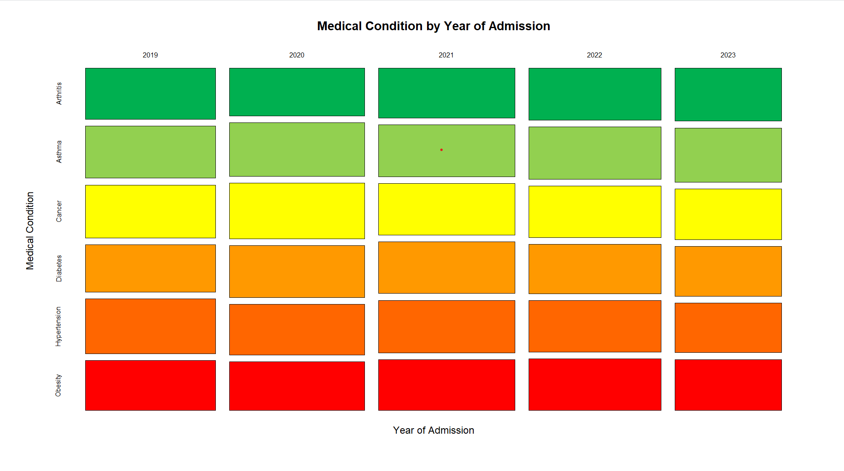

The mosaic plot showing the medical condition by year of admission does not appear to be evenly distributed across each condition for all years. While the general pattern remains relatively consistent, there are some noticeable variations worth pointing out:

1. The green bars representing the "Arthritis" condition seem to maintain a fairly constant proportion across the years.
2. For the "Asthma" condition (represented by the lime green bars), there appears to be a slight decrease in proportion from 2021 to 2022 and 2023.
3. The yellow bars representing the "Cancer" condition show a relatively stable proportion until 2022, where there seems to be a minor increase compared to previous years.
4. The orange bars for the "Diabetes" condition exhibit a slight increase in proportion from 2019 to 2020, followed by a relatively consistent pattern in the subsequent years.
5. The "Hypertension" condition, represented by the darker orange bars, appears to have a slightly higher proportion in 2020 compared to other years, which could potentially be related to the COVID-19 pandemic.
6. The red bars representing the "Obesity" condition seem to maintain a relatively stable proportion across all years.

While the overall pattern may appear generally consistent, these subtle variations in the proportions of certain medical conditions across different years could be indicative of changes in factors such as disease prevalence, population demographics, or healthcare policies and practices.

1. Calendar Map

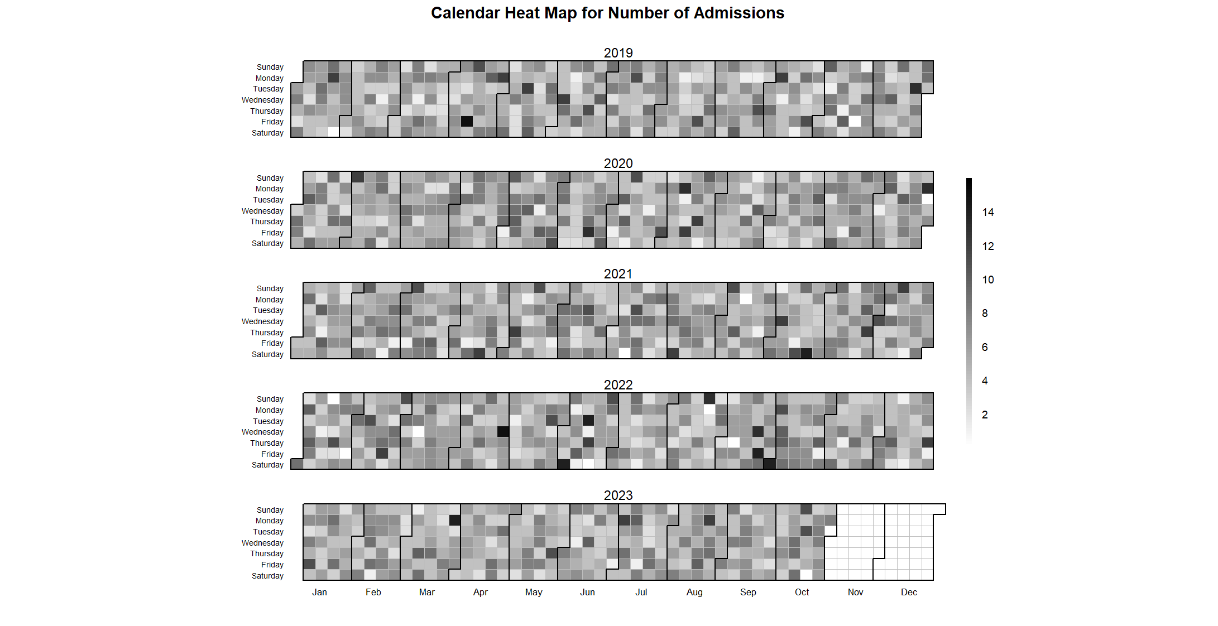

Based on the calendar heat map for the number of admissions, I can observe the following trends and insights:

1. Seasonality: There appears to be a seasonal pattern in the number of admissions. The darker shades (indicating higher admissions) tend to be more concentrated during the winter months (December, January, and February) across multiple years. This could suggest an increase in admissions during the colder months, possibly due to seasonal illnesses or weather-related incidents.
2. Weekly patterns: Within each year, there seems to be a recurring weekly pattern. Darker shades are more prominent towards the end of the week (Friday and Saturday), indicating higher admissions during these days. This could be attributed to an increased likelihood of accidents, emergencies, or other health-related incidents occurring during weekends.
3. Year-over-year trends: While the seasonal and weekly patterns are consistent across years, the overall intensity of the heat map appears to decrease slightly from 2019 to 2023. This could suggest a gradual reduction in the overall number of admissions over the years, potentially due to factors such as improved public health measures, changes in population demographics, or changes in hospital policies or operations.
4. Outliers: There are a few instances of darker shades appearing outside of the typical seasonal and weekly patterns, such as in the middle of the week or during the summer months. These outliers could represent isolated events or anomalies that may warrant further investigation to understand the underlying causes.